Khangai Herds 4- moving encampments

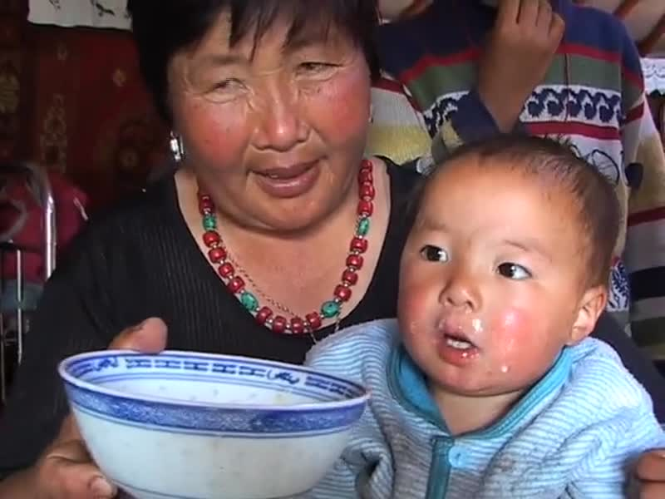

### identifier

fd3fa4f4-3cbc-4345-8f67-8b3773797aa6

### creator

Fijn, Natasha

### type

Moving Image

### coverage

Mongolia

### description

This fourth segment of Khangai Herds features two separate nomadic family encampments in the valleys of the Khangai mountains of Mongolia. Extended families move with the dramatic change of seasons in order to find the best pasture for their herd animals. The first part 'Moving Encampments by Ox' shows Choijo's encampment packing up the entire family home and moving by ox cart to an autumn encampment. The second part 'Moving with the Herd Animals' features Dogsomjav moving the herd animals to new pastures following a broad river valley.

### publisher

### source

<https://vimeo.com/14312685>

### rights

<https://creativecommons.org/licenses/by-nc-nd/3.0/>

### subject

Living with Herds

co-domestic

domestication

encampment

ethnography

herd animal

herding

human-animal

khangai herds

observational film

ox

pastoralism

pasture

visual

yak

### date

2010-08-21

### language

Mongolian

### format

video/mp4

### contributor

### original filename

Khangai Herds 4- moving encampments.mp4

### remote embed url

https://player.vimeo.com/video/14312685

### relation

### extent

69.4MiB

817.666667